Mini Frequency Inverter Delivers High Performance in a Tiny Package

WEG has added the CFW100 mini frequency inverter to its line of frequency inverters. This compact inverter is available in three sizes (A, B and C) for rated motor power from 0,18 to 0,75 kW and rated current from 1.6 to 4.2 A.

ith a height of 100 to 126 mm, a width of 55 mm and a depth of 129 mm, the CFW100 units are among the smallest frequency inverters currently available offering many applications at the user’s fingertips. The mini frequency inverters with integrated micro-PLC are particularly suited to simple technical applications in the commercial and consumer sector, such as swimming pool pumps, motorised hospital beds, lift doors and fitness equipment, as well as small fans or mixing machines and special-purpose machines. With its combination of extensive functionality and extremely small size, the CFW100 is easy to integrate into electrical cabinets and machines. This gives users an especially compact and cost-effective solution for controlling the speed of three-phase induction motors.

Along with the integrated micro-PLC, which supports IEC 61131-3 compatible programming, the CFW100 features an intuitive human-machine interface (HMI) with an LCD display. The plug-and-play design of the new frequency inverter makes installation and commissioning especially easy. As part of the modular CFW100 platform architecture, WEG offers various plug-in base terminals, including USB and Modbus RTU communication interfaces, to facilitate easy access to major field bus systems such as Modbus, DeviceNet or CANopen. Extension modules are also available to enable remote control of the device with an HMI/keypad or an infrared remote control. An optional flash memory card with integrated copy and paste functions allows parameter data sets to be saved and transferred conveniently. A Bluetooth link can also be implemented with an accessory plug-in module. The low-maintenance device concept additionally includes an easily replaceable ventilation module for size B and C units. Another bonus feature is the SuperDrive G2 setup software for free downloading on www.weg.net.

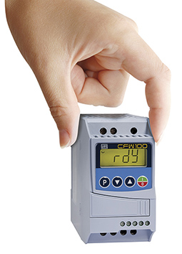

Figure 1: WEG’s new CF100 mini frequency inverter – many applications at your fingertips

