**WEG expands hazardous area range with new Increased Safety Ex e motors**

WEG, a leading global manufacturer of motor and drive technology, has added a new Ex e (Increased Safety) version to its W22X line of hazardous area motors to meet the growing demand in Europe for more cost-effective yet energy-efficient classified area equipment. The motor is available in both IE2 and IE3 energy efficiency versions and – unlike most increased safety motors available on the market – has certification which permits them to be operated in combination with a variable speed drive (VSD), enabling companies operating in the oil and gas, chemical and pharmaceutical industries (among others) to reduce their energy costs.

“We are committed to helping motor users ensure product safety whilst keeping running costs down when it comes to operating essential equipment such as pumps, fans, compressors and mixers in hazardous areas,” comments Andrew Glover, European LV Motors Product Manager. “With this in mind, we want to be as flexible as possible in satisfying the diverse requirements and specifications of the market and we are one of the few manufacturers capable of offering such a broad range of safe, efficient and reliable hazardous area motors in line the latest EU and international regulations.”

Manufactured in accordance with the latest edition of IEC 60079-7:2015 (Part 7: Equipment protection by increased safety ‘e’), the W22Xe line is available in frame sizes from 63 to 355 and rated outputs up to 250 kW. In parallel, a version in compliance with the recommendations of the German industrial association Verband der Industriellen Energie- und Kraftwirtschaft (VIK) can be offered.

Both ATEX and IECEx product certification is provided for the W22Xe line through SGS BASEEFA, with degrees of protection up to IP66 and ambient temperature range -55°C to +60°C covered within the scope.

The housings of all motors in the W22X range feature an advanced cooling system with cooling fans that reduce noise emissions while significantly increasing heat dissipation, contributing to higher energy efficiency. Mechanical strength is enhanced by sturdy integrated mounting feet to ensure further reliability and durability.

With a range of outputs up to 5.6 MW and IEC frame sizes 71 to 800, the W22X series offers users a hazardous area motor for virtually every application, even in extreme operating conditions such as ambient temperatures from -55°C to +80°C and altitudes up to 5,000 m above sea level.

For more information on WEG visit [www.weg.net/uk](http://www.weg.net/uk).

Follow WEG at  Description: Description: Description: Description: Description: Description: Description: Description: Description: Description: Description: Description: Description: Description: Description: Description: Description: Description: Description: Description: Description: Description: Description: Description: Description: Description: Description: Description: Description: Description: Description: Description: Description: Description: Description: Description: Description: Description: Description: Description: Description: Description: Description: Description: Description: Description: Description: Description: Description: cid:image009.jpg@01CE8155.D3CFD760   Description: Description: Description: Description: Description: Description: Description: Description: Description: Description: Description: Description: Description: Description: Description: Description: Description: Description: Description: Description: Description: Description: Description: Description: Description: Description: Description: Description: Description: Description: Description: Description: Description: Description: Description: Description: Description: Description: Description: Description: Description: Description: Description: Description: Description: Description: Description: Description: Description: cid:image011.jpg@01CE8155.D3CFD760  Description: Description: Description: Description: Description: Description: Description: Description: Description: Description: Description: Description: Description: Description: Description: Description: Description: Description: Description: Description: Description: Description: Description: Description: Description: Description: Description: Description: Description: Description: Description: Description: Description: Description: Description: Description: Description: Description: Description: Description: Description: Description: Description: Description: Description: Description: Description: Description: Description: cid:image010.jpg@01CE8155.D3CFD760

**Photo caption:**

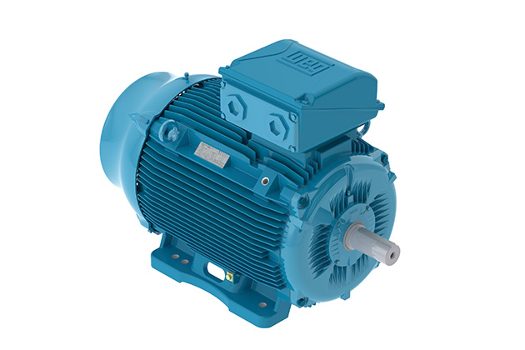

**WEG006501_image1:** New increased safety Ex motors W22Xeare available in frame sizes from 63 to 355 and with rated outputs up to 250 kW

## About WEG

WEG is one of the largest global manufacturers of electric equipment, having five main Business Units: Motors, Energy, Transmission and Distribution, Automation and Coatings.  The company employs over 30,000 people worldwide and in 2014 achieved global sales of US$ 3.34 billion, representing success across a wide range of product groups.  These include the latest generation of transformers, LV control gear, generators, gear motors, inverter drive systems, soft starters, LV/MV and HV motors, ATEX-compliant explosion proof motors, smoke extraction motors and full turnkey systems.

Its power generation, transmission and distribution solutions enable those across many industries, especially in the oil & gas, water, power distribution, chemical and petrochemical markets, to operate more efficiently, and to reduce energy usage, carbon emissions and environmental impact. In addition, WEG provides full solutions for renewable energy projects, producing complete wind turbine and solar energy systems.

**Editorial Contact**

Marco Giudici, Technical Publicity  
Tel: +44 (0)1582 390991   
Email: [mgiudici@technical-group.com](mailto:mgiudici@technical-group.com)

**Company Contact**

Marek Lukaszczyk, WEG (UK) Ltd   
Tel: +44(0)1527 513800 Fax: +44(0)1527 513810  
Email:  [wegsales@wegelectricmotors.co.uk](mailto:sclarke@technical-group.com)

Web: [www.weg.net](http://www.weg.net)/uk