WEG Motor Scan enables predictive maintenance of electric motors
At SPS IPC Drives in Nuremberg, WEG presented their condition monitoring technology for easy real-time monitoring of electric motors.
WEG, a worldwide leading manufacturer of drive technology, presented WEG Motor Scan at this year’s edition of SPS IPC Drives. This retrofittable condition monitoring solution enables real-time monitoring of WEG electric motors via a smart device app, based on acquired operating data. WEG Motor Scan easily and economically facilitates predictive maintenance measures that lead to extended motor lifetime and enhanced plant availability.
Operational anomalies immediately visible
WEG Motor Scan captures operating data in real time and is able to monitor any desired number of motors via the app, which is available for Android and iOS. Based on the acquired operating data, plant operators and maintenance staff can schedule and carry out predictive maintenance activities based on the actual motor condition.
The collected data can be transferred via Bluetooth (and via gateway technologies in future) to a secure cloud, where it can be accessed through a mobile app or a web portal in the form of the WEG IoT Platform. That enables detailed analysis of the monitored motors. The WEG IoT Platform offers extensive analysis tools for fault diagnosis and supports user configuration of warnings. Maintenance staff can thus access real-time data on current motor performance from anywhere, analyze it directly, and act accordingly. In this way WEG Motor Scan contributes to extended motor lifetime and enhanced plant availability.
Easy real-time monitoring with WEG Motor Scan
For real-time monitoring with WEG Motor Scan, users can define a schedule with up to twelve vibration measurements per day. These measurements are performed in real time. Temperature measurements are made every 10 minutes. For practical reasons, analysis is performed on demand because continuous monitoring would consume too much battery capacity. Along with surface temperature and operating time, WEG Motor Scan measures motor vibrations using three-axis vibration measurement in the range of 1 to 3 kHz. The motor condition is then determined by frequency spectrum analysis (FFT). In future, the solution will be augmented with the parameters motor speed (rpm), start and stop times, load and efficiency. Future plans also include measurement capability for energy efficiency and motor condition parameters such as unbalance and misalignment.
Fast retrofit and suitable for extreme conditions
With dimensions of 44 × 38 × 25 mm, the small WEG sensor can be retrofitted in a predefined location on motors with IEC frame sizes from 63 to 450. The WEG Motor Scan module is mounted using a 5.9 mm drilled hole in the motor cooling fin. WEG Motor Scan features IP66 protection rating, is suitable for numerous industrial applications, and operates reliably even under extreme conditions such as ambient temperatures from -40 to +80°C.
WEG at SPS IPC Drives 2018: Hall 3A, Stand 466

Follow WEG on   

Figure captions
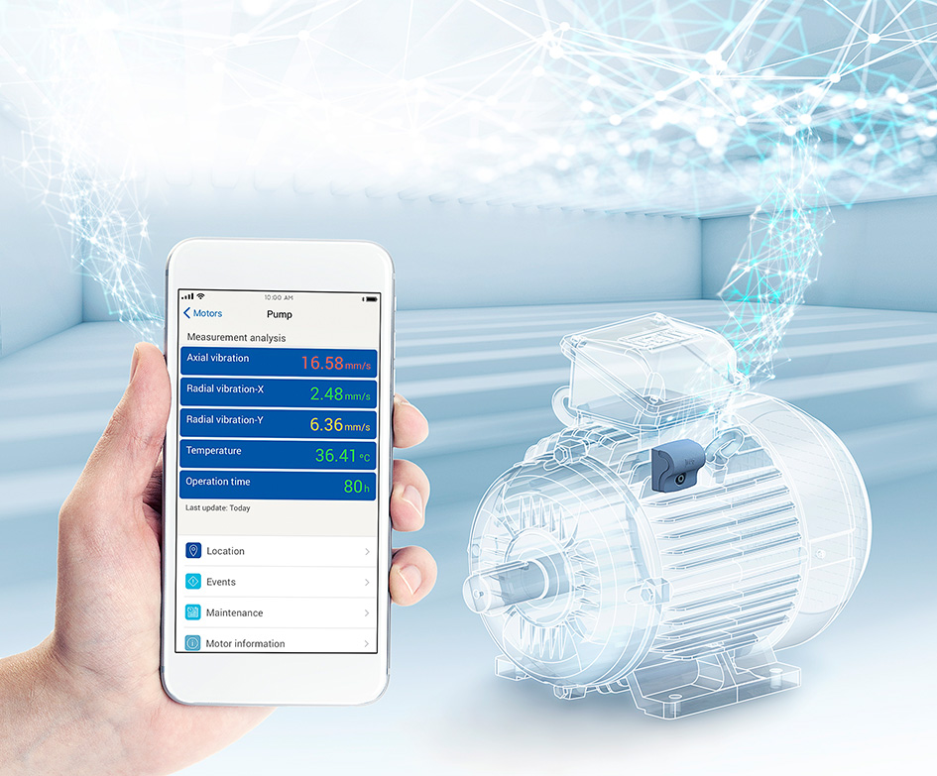
WEG001601_Image1: WEG Motor Scan enables real-time monitoring based on acquired operating data, enabling predictive maintenance measures leading to extended motor lifetime and enhanced plant availability.

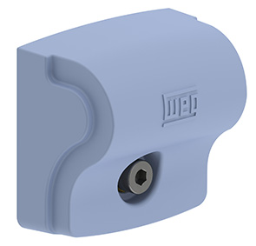
WEG001601_Image2: With dimensions of 44 × 38 × 25 mm, WEG Motor Scan can be retrofitted on WEG motors with IEC frame sizes from 63 to 450.
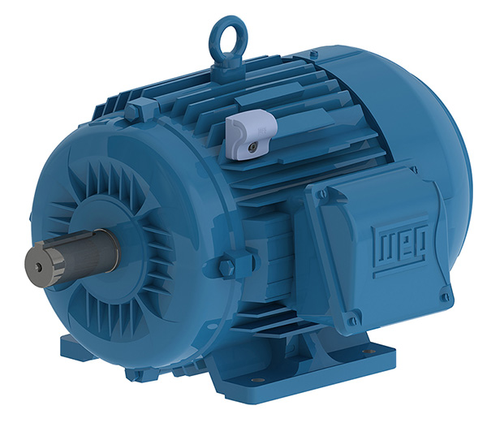
WEG001601_Image3: WEG Motor Scan measures and logs the surface temperature, operating time and vibrations of WEG motors.

About WEG
WEG is one of the largest global manufacturers of electric equipment, having five main Business Units: Motors, Energy, Transmission and Distribution, Automation and Coatings. The company employs over 30,000 people worldwide and in 2017 achieved global sales of R$ 9.5 billion, representing success across a wide range of product groups. These include the latest generation of transformers, LV control gear, generators, gear motors, inverter drive systems, soft starters, LV/MV and HV motors, ATEX-compliant explosion proof motors, smoke extraction motors and full turnkey systems.
Its power generation, transmission and distribution solutions enable those across many industries, especially in the oil & gas, water, power distribution, chemical and petrochemical markets, to operate more efficiently, and to reduce energy usage, carbon emissions and environmental impact. In addition, WEG provides full solutions for renewable energy projects, producing complete wind turbine and solar energy systems.

Editorial Contact
Ian Jarrett, Publitek
Tel: +44 (0)1582 390980
Email: ian.jarrett@publitek.com

Company Contact
Marek Lukaszczyk, WEG (UK) Ltd
Tel: +44(0)1527 513800 Fax: +44(0)1527 513810
Email: wegsales@wegelectricmotors.co.uk
Web: www.weg.net

