WEG W22 - Motors for the Present and Future.

The currently effective energy efficiency standard IE2 is going to be replaced by IE3 in the year 2015. From this time only IE3-motors or IE2-motors with speed control are allowed to be distributed within the EU. This standard is subject to 2, 4, 6-pole motors for the power range of 7.5 - 375 kW.

Among other aspects, the product line W22 of WEG (see picture 1) has been developed according to those requirements. WEG possesses the technology to combine both energy efficiency classes IE2 and IE3 into one motor housing.

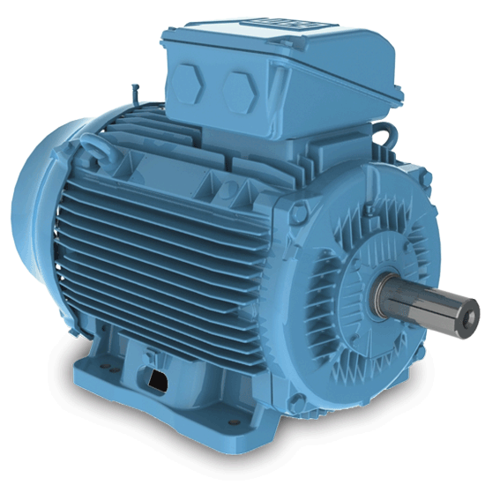
Picture 1: WEG W22-Motor

User who have to equip plant sections with the new motors from 2015 on, have the big advantage, that the IE3 motors can be implemented without any changes in the construction of the plant.

Apart from the enhanced degree of efficiency and thus the considerably reduced product life-cycle costs, the compatible motor series saves our customers additional construction- or development costs.

The W22 motor therewith is an unbeatable guarantor for longevity, highest energy efficiency and compatibility; in other words a drive concept for the present and future.

The energy saving design – amortisation in shortest time:

Around 90% of the lifecycle costs an electric motor engenders during its operation time is accounted for energy consumption - in comparison to the residual 10% for acquisition-, installation- and maintenance costs. This is why we put special emphasis on energy efficiency as we develop our motors. The available designs comply with all requirements of various countries worldwide. Thanks to the especially low energy consumption the investment costs amortise in the shortest of time.

Usage within frequency inverter operation – the unique isolation system WISE®:

The unique isolation system WISE® of the new W22 line provides for highest dielectric strength of the winding and supports the operation at the frequency inverter for a line voltage of up to 575V without the need for further adaption. Thus it offers special flexibility and prolongs the lifespan of the motor.

W22 Standard features:
- Rated power: 0.12 up to 500 kW
- Sizes: 63 up to 355A/B
- Efficiency classes: IE1, IE2 and IE3 according to the European directive of IEC60034-30
- Pole numbers: 2, 4, 6, and 8
- Frequencies: 50 Hz or 60 Hz
- Cooling type: TEFC (closed and surface-cooled)
- Voltage: 50 Hz: 220-240/380-415 V (up to size 100L) / 380-415/660-690 V (112M up to 355A/B)
60 Hz: 460V (63 up to 355A/B)
- Service factor: 1.00
- Ambient temperature: -20°C up to +40°C at 1000m a.s.l.
- Isolation class: F (AT=80 K)
- Protection class: IP55
- Sizes: B3, B5 and B14
- Isolation system WISE® - suited for inverter usage
- Thermistor (1 per phase) for sizes160M up to 355A/B
- Cage motor in aluminium die cast
- V-ring sealing for sizes 63 up to 200L or WSeal® for sizes 225S/M up to 355A/B (see picture 2)
- Relubrication device for sizes 225S/M up to 355A/B
- Nameplates made of stainless steel
- Ventilation cowl made of sheet steel from size 63 up to 132M/L, made of grey cast iron from size 160M up to 355A/B

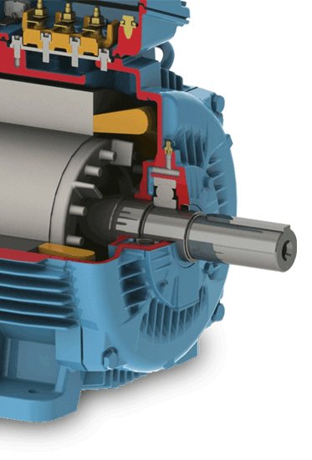
Picture 2: Sealing system WSeal®

