Drive Solutions for Bridge- and Gantry Cranes

Cranes, conveyors for discontinued conveyance of loads, need special drive elements with integrated brakes and frequency inverters that ensure soft acceleration- and deceleration processes. Due to the compactness, shaft mounted geared motors with elastic torque arms are often used for the driving of crane- and trolley traveling gears. Watt geared motors with WEG frequency inverters or soft starters offer the WATT customer the entire drive range for this application.

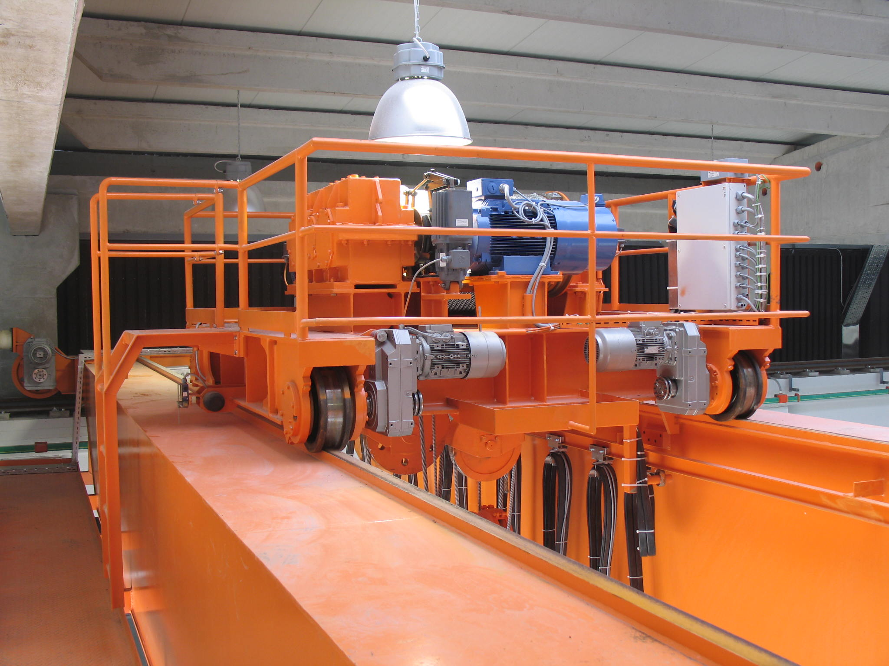
Picture 1: Trolley traveling gear of a bridge crane with Watt shaft mounted geared motors

Gears in crane construction:

Compared to drive elements of continuous conveyors, geared motors in crane construction are exposed to extremely varying loads.
According to frequent starting- and braking procedures or buffered start-ups, the components have to be safely dimensioned. The load spectrum with its phases of acceleration, equilibrium with or without load and deceleration has to be considered together with possible occurring load peaks.
Therefor for every operating phase the required torque is ascertained and a necessary rated torque is determined.

A geared motor is positioned on every wheel. This has the advantage of ending up with a smaller gear than those with a central drive. Additional drive elements like chain wheel and chains can be left out. In shaft-mounted design, the gear can be directly mounted onto the shaft or even used as bearing area for the drive wheel.

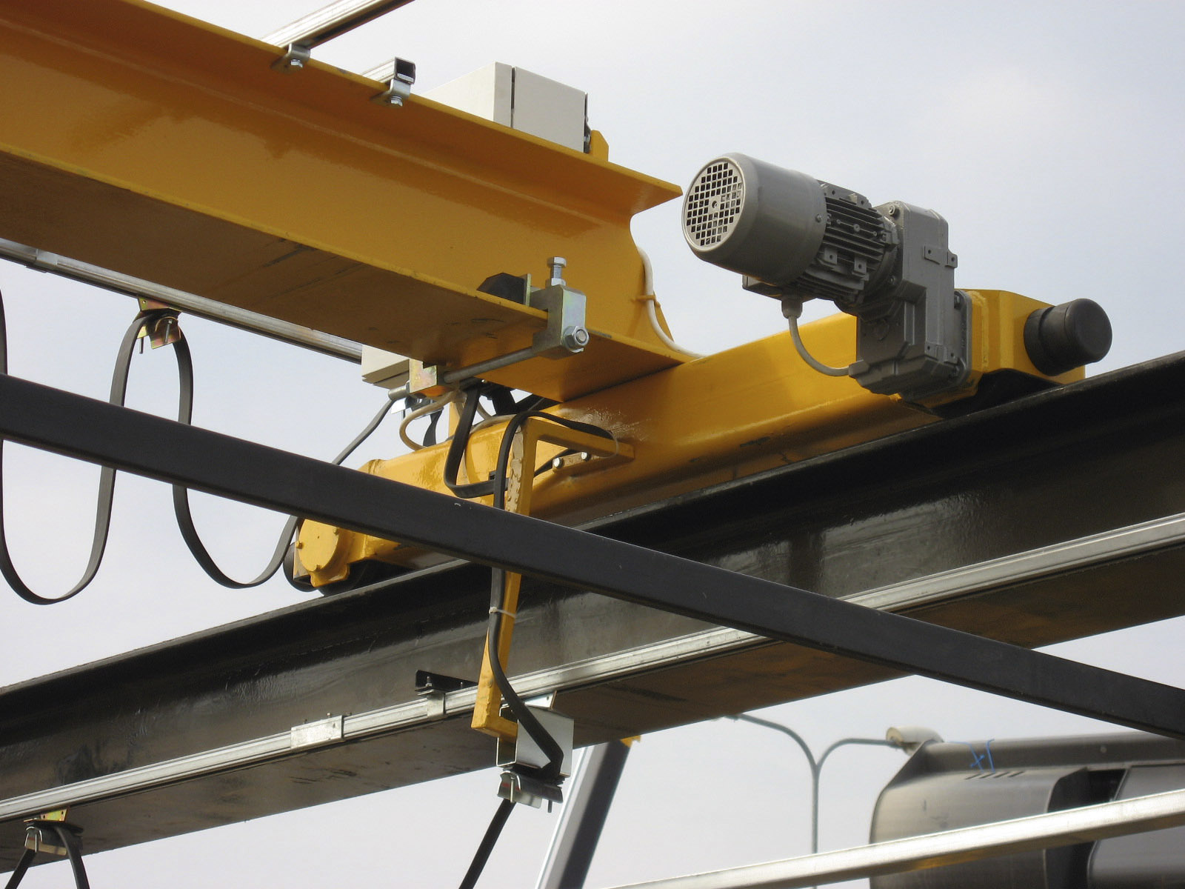
Picture 2: Crane gear with brake-geared motor from Watt Drive

Modular gear system with uncountable motor options:

The modular geared motor system from Watt Drive, with shaft mounted geared motors of up to 55kW and 14,000Nm rated torque includes uncountable features for this very application. Reliably dimensioned components with high power density at compact dimensions offer the customer enormous application advantages.

Gear characteristics:

Power range: 0.12 – 55kW
Torque range: 27 – 14,000Nm
Reduction range: 0.8 – 18,600
Customer interface: Hollow or output shaft, hollow shaft with shrink disc
Finish: Corrosion category C1 – C5-M acc. DIN 12944-5
Lubricant: Mineral or synthetic, for varying temperatures

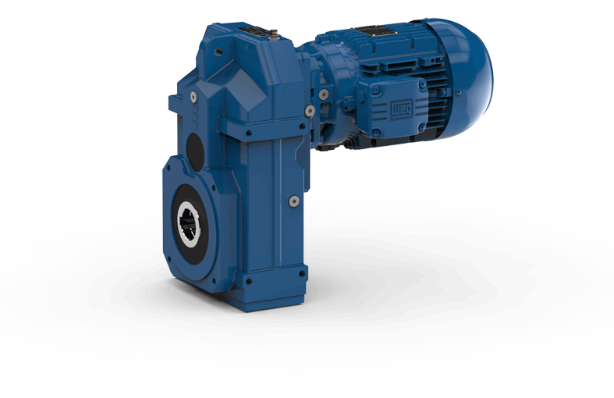
Picture 3: Watt Drive shaft mounted geared motor

