WEG’s CFW11W offers up to 40% higher power than conventional inverter drives
WEG, a leading supplier of drive technology, has presented its CFW11W variable speed drive at SPS IPC Drives exhibition for the first time. The water-cooled drive offers up to 40% higher power in a more compact size than standard air-cooled inverters, enabling manufacturers across a wide range of industries to increase efficiency and optimise processes.

Space on production plants is often limited, with only minimal room available for the installation of automation components. Furthermore, increasingly powerful drive systems require modern and efficient cooling methods. The modular, water-cooled CFW11W frequency inverter from WEG offers a solution to these challenges.

With power ratings from 450 kW to 2,800 kW, CFW11W is suitable for low-voltage applications and is ideal for critical and support drive systems. As the inverter is water-cooled, there is no need for fans, which offers significant size and cost savings compared to air-cooled models.

Available with an IP54 protection rating as a minimum, the CFW11W is robust, with enhanced cooling efficiency enabling it to operate without power loss at temperatures of up to 45°C. Additionally, the modular architecture of the CFW11W allows up to five power modules to be incorporated in a switchgear unit and controlled using a single operator panel, allowing the inverter to be optimally adapted to specific customer power requirements.

“Our water-cooled CFW11W inverters are used wherever space is tight and suitable process water is already available,” says Johannes Schwenger, Head of Drive Systems Product Management at WEG.
“Compared to conventional models of the same size the CFW11W inverters deliver significantly higher power. For example, a water-cooled inverter with a 2.8 MW power rating has smaller dimensions than an air-cooled model with a 2 MW power rating.”

Aside from water cooling, the CFW11W inverters are structurally identical to WEG’s standard CFW11M models in the same product family. The inverters support open-loop vector control or field-oriented motor control with rotary transducer feedback for extremely high speed and torque accuracy. This enables precise torque settings even at low motor speeds, virtually up to the stall limit of the motor.

All functions for the effective protection of low-voltage motors are integrated in the devices. This makes the drives suitable for any task which requires precision and energy savings. The CFW11W is extremely easy to operate as it has an integrated user interface (HMI) with a backlit graphical display and software-configurable function keys. With a wide selection of plug-in extension modules as well as plug-and-play functions, it can be adapted to customer needs quickly and easily using the USB port.

For more information on WEG’s CFW11W and variable speed drives visit www.weg.net.

Figure captions:
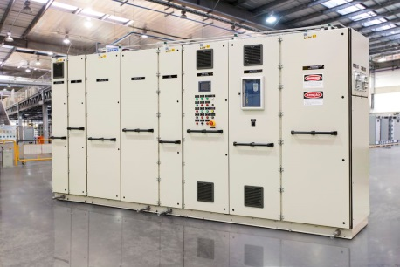
WEG3116_1: The CFW11W is available as a turnkey package solution in a sturdy, vibration-protected cabinet, as well as individual units

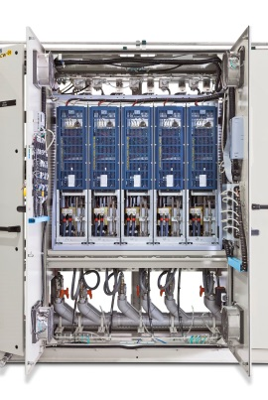
WEG3116_2: The water-cooled CFW11W allows users to significantly reduce size or increase output power compared to standard models

About WEG

WEG is a major global player in drive technology as well as in the power distribution, automation and control sector. The company’s global sales now exceed US $3-billion, representing increasing global success across a wide range of product groups. These include the latest generation of transformers, LV control gear, generators, gear motors, inverter drive systems, soft starters, LV/MV and HV motors, ATEX- compliant explosion proof motors, smoke extraction motors and full turnkey systems.

Editor Contact
Marco Giudici, Technical Publicity
Tel: +44 (0)1582 390991
Email: mgiudici@technical-group.com

Company Contact
Marek Lukaszczyk, WEG Electric Motors (UK) Ltd
Tel: +44(0)1527 513800 Fax: +44(0)1527 513810
Web: www.weg.net
Email: wegsales@wegelectricmotors.co.uk

